**Topics: Descriptive Statistics and Probability**

1. Look at the data given below. Plot the data, find the outliers and find out $μ, σ, σ^{2}$

|  |  |
| --- | --- |
| **Name of company** | **Measure X** |
| Allied Signal | 24.23% |
| Bankers Trust | 25.53% |
| General Mills | 25.41% |
| ITT Industries | 24.14% |
| J.P.Morgan & Co. | 29.62% |
| Lehman Brothers | 28.25% |
| Marriott | 25.81% |
| MCI | 24.39% |
| Merrill Lynch | 40.26% |
| Microsoft | 32.95% |
| Morgan Stanley | 91.36% |
| Sun Microsystems | 25.99% |
| Travelers | 39.42% |
| US Airways | 26.71% |
| Warner-Lambert | 35.00% |

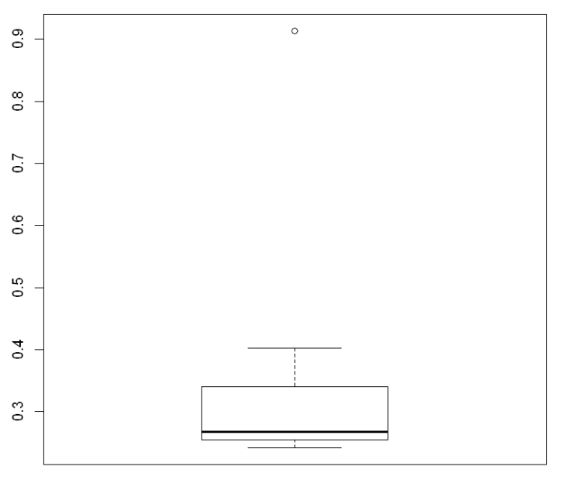

Mean = 0.332713333333333

Sd = 0.16945400921222

Var = 0.0287146612380952



Answer the following three questions based on the box-plot above.

1. What is inter-quartile range of this dataset? (please approximate the numbers) In one line, explain what this value implies.

ANS: IQR is the range between upper quartile (Q3) and lower quartile (Q1)

IQR= Q3-Q1= 12-5 = 7

50% of the data lies between IQR

Second Quartile Range is the Median Value

1. What can we say about the skewness of this dataset?

ANS: Skewness = Positive

Right-Skewed median is towards the left side it is not normal distribution

1. If it was found that the data point with the value 25 is actually 2.5, how would the new box-plot be affected?

ANS: There will be no outlier if the value of 25 was actually 2.5. Subsequently, mean and median needs to be calculated to see if there is any shift in data



Answer the following three questions based on the histogram above.

1. Where would the mode of this dataset lie?

ANS: The mode of this data set lie in between 5 to 10 and approximately between 4 to 8 .

1. Comment on the skewness of the dataset.

ANS: Skewness = Positive

Right-Skewed

1. Suppose that the above histogram and the box-plot in question 2 are plotted for the same dataset. Explain how these graphs complement each other in providing information about any dataset.

ANS: They both are right-skewed and both have outliers the median can be easily visualized in box plot where as in histogram mode is more visible

1. AT&T was running commercials in 1990 aimed at luring back customers who had switched to one of the other long-distance phone service providers. One such commercial shows a businessman trying to reach Phoenix and mistakenly getting Fiji, where a half-naked native on a beach responds incomprehensibly in Polynesian. When asked about this advertisement, AT&T admitted that the portrayed incident did not actually take place but added that this was an enactment of something that “could happen.” Suppose that one in 200 long-distance telephone calls is misdirected. What is the probability that at least one in five attempted telephone calls reaches the wrong number? (Assume independence of attempts.)

ANS:

X = probability of 1 call misdirected out of 200

Probability of occurring of X = 1/200

P(X)= 1/200

Probability of having at least one successful call will be

1-P(X)= 1-1/200= 199/200= 0.967

As every event is independent of other event the probability will be

1- (0.967)^5

0.02475 = 2% chance.

1. Returns on a certain business venture, to the nearest $1,000, are known to follow the following probability distribution

|  |  |
| --- | --- |
| x | P(x) |
| -2,000 | 0.1 |
| -1,000 | 0.1 |
| 0 | 0.2 |
| 1000 | 0.2 |
| 2000 | 0.3 |
| 3000 | 0.1 |

1. What is the most likely monetary outcome of the business venture?

ANS:

The most likely monetary outcome of the business venture is 2000$ As for 2000$ the probability is 0.3 which is maximum as compared to other

1. Is the venture likely to be successful? Explain

ANS: if Success == positive returns as a measure

Then there is a 60% probability that the venture would be profit.p(x>3000)+p(x>2000)+p(x=1000) =(0.3+0.2+0.1=0.6=>0.6*100=>60%).

Yes, since the probability that the venture will make more than 0 or a profit is

1. What is the long-term average earning of business ventures of this kind? Explain

ANS:

The long-term average is Expected value = Sum (X * P(X)) = 800$ (-2000*0.1)+(-1000*0.1)+(0*0.2)+(1000*0.2)+(2000 *0.3)+(3000*0.1)=800

the long-term average earning for these type of ventures would be around $800

1. What is the good measure of the risk involved in a venture of this kind? Compute this measure

ANS: The good measure of the risk involved in a venture of this kind depends on the Variability in the distribution. Higher Variance means more chances of risk

E(x) = Sum(x*P(x))

E(X^2) =x^2*P(x)

Var (x) = E(x^2) –(E(x))^2

Var(x) =2800000 – 800^2

Var(x) =2160000 (Value is quite high)

Std Deviation = √Var ≈ $ 1870 , so there is risk of around 1870 dollars involved in this business venture.